**SBA 2**

1. Write a program to reverse the String (use char[] or String built in method)

**import** java.lang.*;

**import** java.io.*;

**import** java.util.*;

**public** **class** StringReverseEx1 {

**public** **static** **void** main(String[] args)

{

String input = "Anagha_Mohan";

// toCharArray is used to convert String to character array

**char**[] try1 = input.toCharArray();

**for** (**int** i = try1.length - 1; i >= 0; i--)

System.***out***.print(try1[i]);

}

}

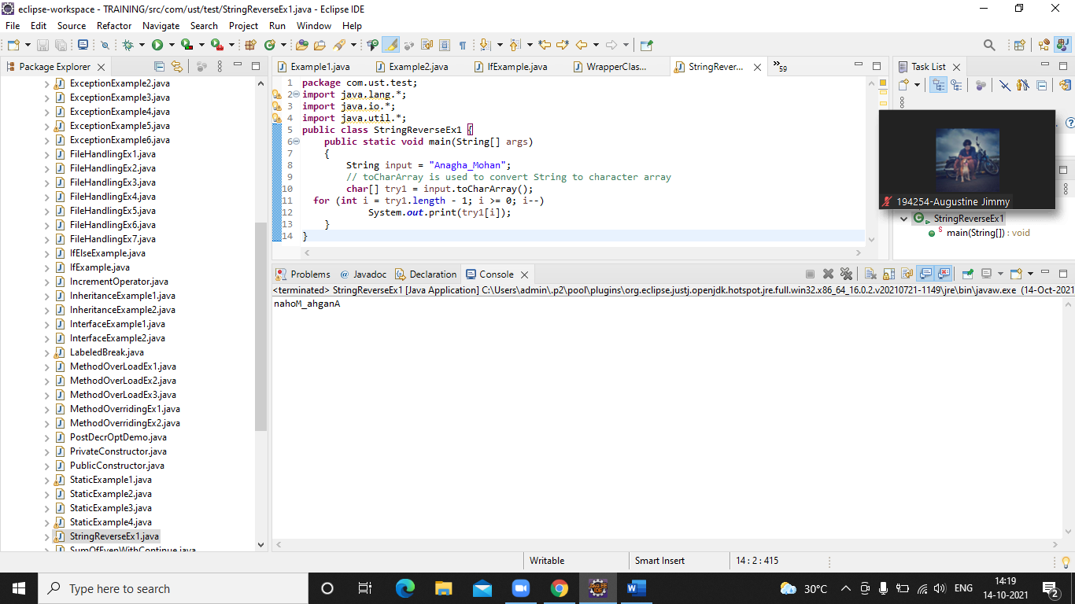

1. Write programs to depict the usage of contains(), length(), replace(), concat(), equals()

* **length() 🡪 used to find the length of the string**

**public** **class** LengthEx {

**public** **static** **void** main(String args[]){

String a="Trivandrum";

System.***out***.println("length is: "+a.length());

}

}

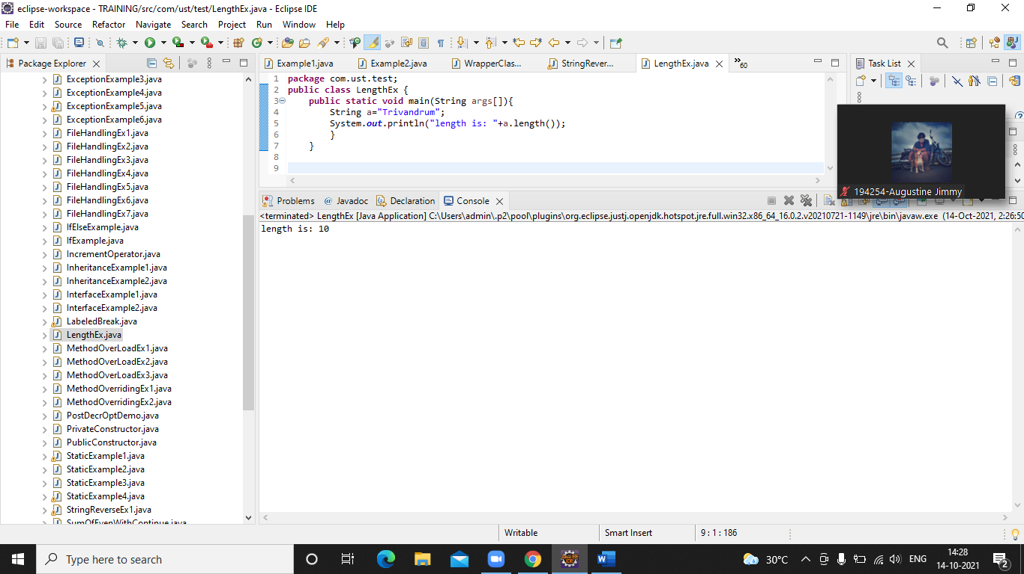

* **replace() 🡪 used to replace old char to new char**

**public** **class** ReplaceEx {

**public** **static** **void** main(String args[]){

String s1="this is a nice book";

String replaceString=s1.replace('i','o');//replace 'i' with 'o'

System.***out***.println(replaceString);

}}

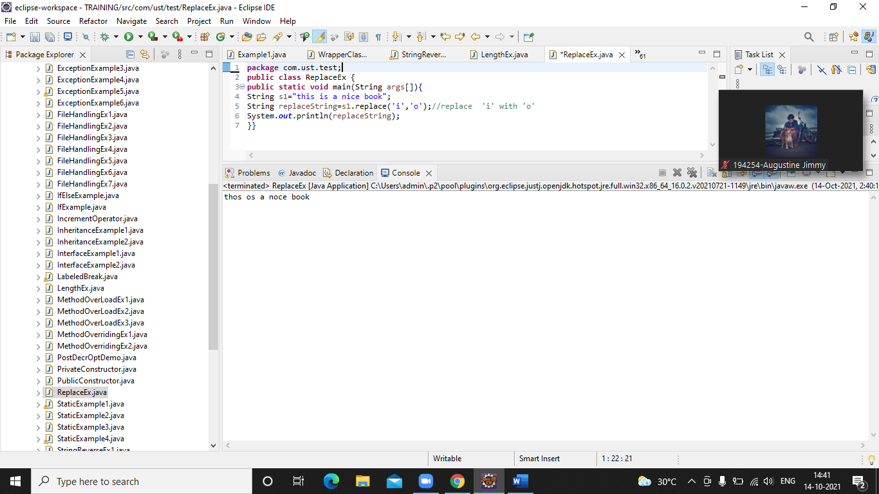

* **equals() 🡪 used to compare 2 strings, return true if the strings are equal otherwise false.**

**public** **class** EqualsEx {

**public** **static** **void** main(String args[]){

String s1="anagha";

String s2="anagha";

String s3="ANAGHA";

String s4="ammu";

System.***out***.println(s1.equals(s2));//true, because content and case is same

System.***out***.println(s2.equals(s3));//false, case is not same

System.***out***.println(s1.equals(s4));//false, content is not same

}

}

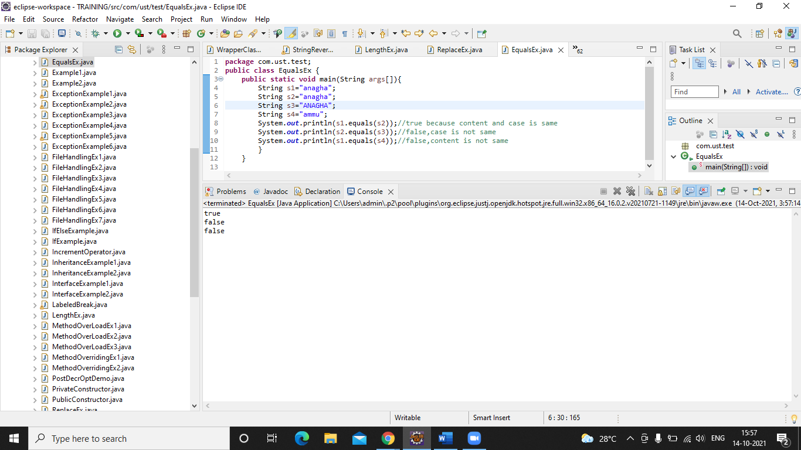

* **concat() 🡪 used to concatenates the specified string to the end of current string.**

**public** **class** ConcatEx {

**public** **static** **void** main(String args[]){

String s1="Everyday ";

String s2="is a new day";

String s3=s1.concat(s2);

System.***out***.println(s3);// Everyday is a new day

}

}

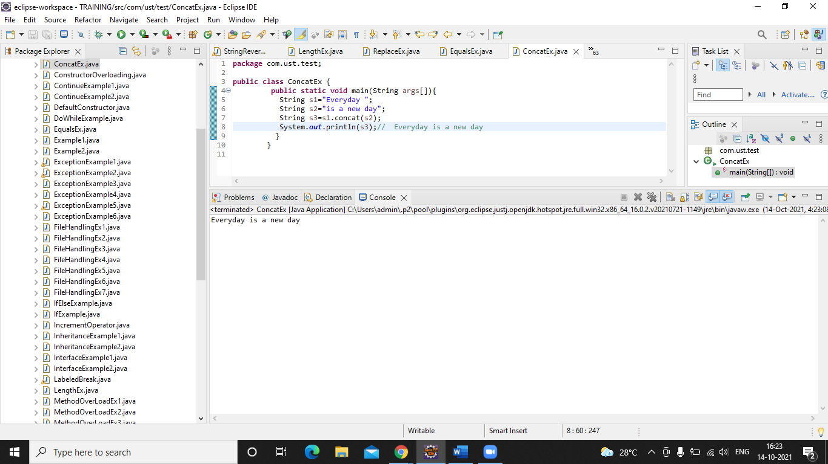

* **contains() 🡪 returns true if the string is there otherwise false**

**public** **class** ContainsEx {

**public** **static** **void** main(String args[]){

String name="Its always the small pieces that make the big picture";

System.***out***.println(name.contains("always the small pieces"));

System.***out***.println(name.contains("make"));

System.***out***.println(name.contains("happy"));

}

}

